# ROI assessment guide

## Project scenario

As a digital marketing analyst for Friska, you analyzed the marketing campaign data for Friska's sustainable deodorant that aimed to increase engagement on Instagram across all segments in the U.S. You came to a conclusion that only a 5% result was reached. You are now in charge of assessing the ROI and should suggest an optimization strategy to improve the results. Remember that as a digital marketing analyst, you should assess every marketing campaign’s ROI on a monthly basis to ensure the campaign’s efficiency and good use of your marketing budget.

## Step-by-step instructions

### Step 1: Conduct data analysis.

Review the campaign data to assess the current situation and ROI.

* **Initial objective:** The goal was to increase engagement on Instagram such as likes, comments, and shares by 20% within 3 months.
* **Actual result**: The campaign achieved only a 5% increase in engagement.

Was the goal to increase engagement achieved? Write your answer in the space below.

| ***Engagement goal: Was it met?*** |  |
| --- | --- |

### Step 2: Calculate ROI.

Here’s what you know about the campaign:

* The revenue generated before the campaign was $20,000.
* The campaign cost $15,000 over 3 months.
* The additional revenue generated from the campaign was 5% of the revenue generated before the campaign.

Use the following formula to calculate ROI:

$\frac{Campaign net profit- Marketing cost}{Marketing cost}∙ 100$

**Net profit** refers to the increased revenue generated from the campaign.

**Marketing cost** refers to the total cost of the influencer partnership campaign.

**Step 1: Calculate the net profit.**

The revenue generated before the campaign was $20,000. The additional revenue generated from the campaign was 5%. You need to determine what the additional revenue was in dollar amount first, so you can add it to the revenue generated before the campaign.

Multiply the revenue generated before the campaign by 0.05. This will be the additional revenue amount in dollars. Write the value in the space below.

| ***(20,000)*(0.05)*** |  |
| --- | --- |

**Step 2: Determine the marketing cost.**

The marketing cost is the total investment made in the influencer partnership campaign. You know the campaign cost $15,000 over 3 months. This is your marketing cost.

**Step 3: Substitute values into the ROI formula.**

You now have all the values to calculate the ROI. Substitute the values into the formula from above to get:

$\frac{1000-15000}{15000}∙100$

**Step 4: Determine the ROI.**

Perform the calculation to determine the ROI.

What is the ROI? Write your answer in the space below.

| ***ROI*** |  |
| --- | --- |

Below is an example of an ROI tracker: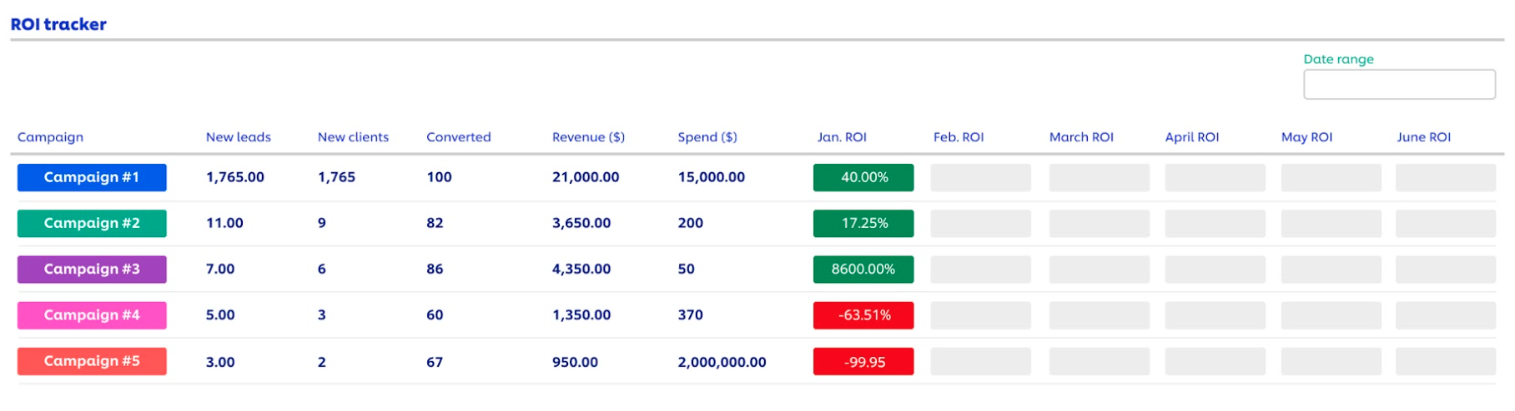

### Step 3: Optimize the strategy.

Given that the initial campaign fell short of its engagement target, it's crucial to optimize the strategy to achieve better ROI results. Here are factors to consider:

* **Influencer selection**:
  + **Micro-influencers**: Consider working with micro-influencers who have a smaller but highly engaged and niche audience. They often provide better ROI with less budget.
  + **Relevance**: Ensure that the influencers chosen align with Friska's brand values and target audience.
* **Content strategy:**
  + **Authentic content**: Encourage influencers to create authentic content that showcases how they genuinely incorporate Friska's sustainable deodorant into their daily lives.
  + **Storytelling:** Ask influencers to tell a compelling story about the product, emphasizing its sustainability and benefits.
  + **User-generated content**: Encourage users to share their own experience with the product, creating a sense of community and trust.
* **Engagement optimization:**
  + **Consistency**: Ensure a consistent posting schedule across influencers to maintain audience engagement.
  + **Engagement monitoring**: Continuously monitor live comments and engage with the audience. Address questions and concerns promptly.
  + **Contests and giveaways**: Run contests or giveaways to incentivize engagement and user-generated content.
* **Analytics and iteration:**
  + **Performance tracking**: Implement robust tracking of engagement metrics and regularly review the data (on a monthly basis for example) to identify trends and areas for improvement.
  + **Iterative approach**: Be willing to adapt and refine the campaign strategy based on real-time performance data.
* **Paid promotion:**
  + **Boost posts**: Consider allocating a budget for promoting influencer posts to a broader audience, especially those with high engagement rates.
  + **Long-term partnerships**: Build long-term relationships with influencers who resonate with the brand. They can become authentic brand advocates over time.
* **Sustainable messaging:**
  + **Highlight sustainability**: Emphasize the sustainable aspects of the deodorant in influencer collaborations, tying it to current environmental concerns.

What strategies would you implement to receive better ROI results in the future? Write your answer in the space below.

| ***Strategies to implement*** |  |
| --- | --- |

### Step 4: Adjust the strategy at regular intervals.

Adjust the strategy as needed based on real-time data and feedback at regular intervals. It’s best to track monthly results and re-evaluate the strategy every month to ensure the current strategy is working to increase ROI. If you do not evaluate and adjust your strategy at regular intervals, this could be a waste of time and resources and have negative effects on ROI.

If you did not see any improvement over a 1 month period, what adjustments would you make to your strategy and why? Write your answer in the space below.

| ***Adjustments to campaign strategy*** |  |
| --- | --- |

When you’re ready, go back to [the assignment](https://www.coursera.org/learn/campaign-performance-reporting-visualization-improvement/assignment-submission/Q1oYC/roi-assessment) to complete the reflective questions.